Cashmore Early Years Centre Newsletter
May 2019

Telephone: 0117 3534295 Facebook: Cashmore early years centre
Website: www.cashmoreearlyyearscentre.co.uk Email: cashmore@bristol-schools.uk
Website: www.cashmoreearlyyearscentre.co.uk Email: cashmore@bristol-schools.uk

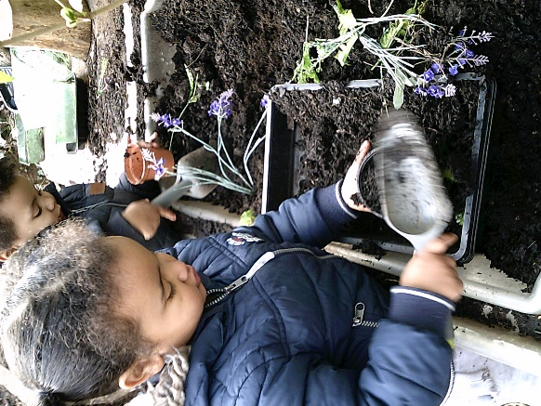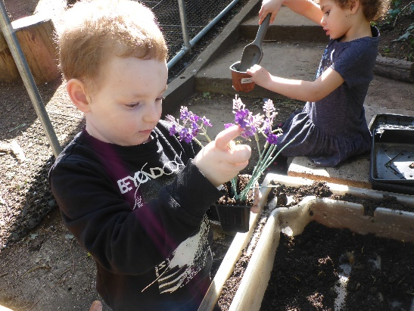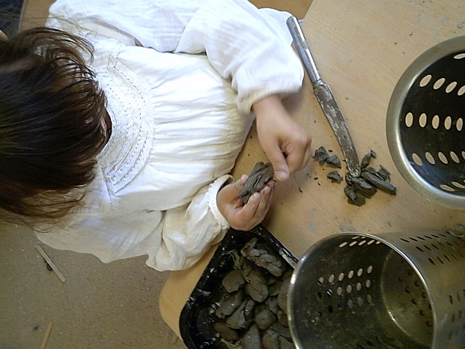
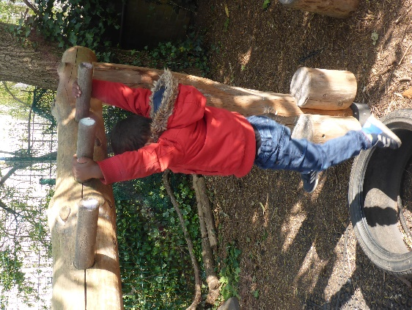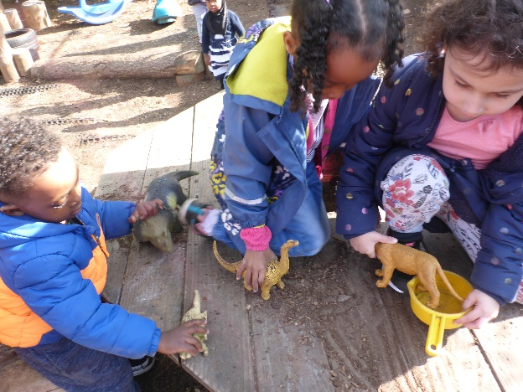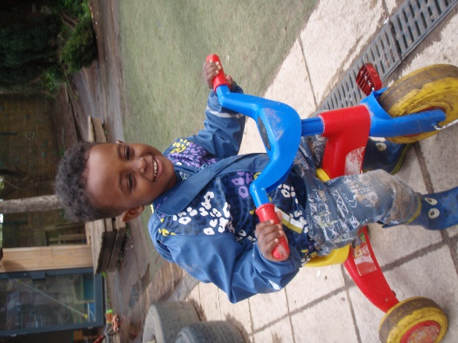
Spare clothes

Please leave a bag on your child’s peg with lots of spare clothes, especially if your child is toilet training. If your child is in nappies, please can parents remember to include wipes and nappies.

Important Dates
Monday 6 May – School CLOSED for Bank Holiday
Speech and Language Drop-in - Tuesday 14 May 1.00-2.30pm Barton Hill Settlement
Monday 27 May to Friday 31 May (inclusive) – School CLOSED for Half Term holiday
Return to School – Monday 3 June
Wednesday 12 June – INSET Day – School CLOSED

Summer safety
When the sun begins to shine (hopefully!) please make sure your child’s shoulders are covered, bring a sun hat and apply sun cream before your child comes to school. Some sun creams are available which will last all day. If your child is in all day you can send in sun cream (labelled with your child’s name) and the staff will supervise whilst they apply it themselves. It might be a good idea for them to practice this at home first. Please do not leave sun cream in your child’s bag but ensure it is given to your child’s key person.
The children spend a lot of time outside: climbing; riding bikes and scooters; playing ball games; gardening and running around. Open-toed sandals, crocs and flip flops are not suitable footwear and can be dangerous.
Lunchboxes
Children are given water to drink at lunchtime so you do not need to include a drink/juice carton in their lunchbox.
Staff and Governor changes
We would like to extend a warm welcome to Naciima who joins us as a full-time Early Years Support Worker.

We would like to welcome Amran Arab to our Governing Body as Parent Governor and we look forward to working with her.
Sponsorship
Colin and Maggie will be running in the Simplyhealth Great Bristol 10k on Sunday 5 May. We are raising money for the redevelopment of the sandpit area at Cashmore and would welcome your sponsorship please. A sponsor form is available at Reception and there is fundraising page on the Facebook page. Thanking you in anticipation.
Snack donations
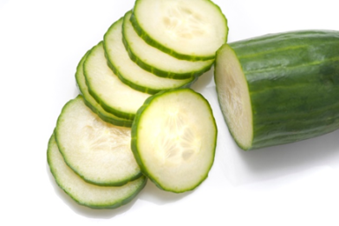
The school provides milk but we rely on donations from parents for snack times during the morning and afternoon sessions. The children eat fresh fruit (e.g. apples, bananas, oranges, pears) or vegetables (e.g. carrots, cucumbers). Your child’s key person will put a slip in your child’s bag the week prior to it being their group’s turn to donate. Please check your child’s bag. Your donations are greatly appreciated.

Vomiting and diarrhoea
If your child’s sibling is ill, please do not bring them into the room. They are welcome to stay in Reception. This is to prevent infection of children in the room.
Toys from home
Please avoid bringing toys from home as children get very distressed if their toy from home gets misplaced.
Wellspring Baby Clinic
Starting from Thursday 2 May, the Wellspring’s Well Baby Clinic will run from its new time of 10.30 am – 12.30 pm. Feel free to drop by to discuss your baby’s health and wellbeing as no appointment is necessary.

