Cashmore Early Years Centre Newsletter
September 2019

Telephone: 0117 3534295 Facebook: Cashmore early years centre
Website: www.cashmoreearlyyearscentre.co.uk Email: cashmore@bristol-schools.uk
Website: www.cashmoreearlyyearscentre.co.uk Email: cashmore@bristol-schools.uk

Welcome back to Cashmore. We hope you have all had a good summer break.
Staff changes
We welcome Char who will be the Key Person in Bear Group on Wednesday afternoon, Thursday and Friday. Amy begins her maternity leave shortly and we would like to wish her the very best of luck and look forward to meeting her baby soon.
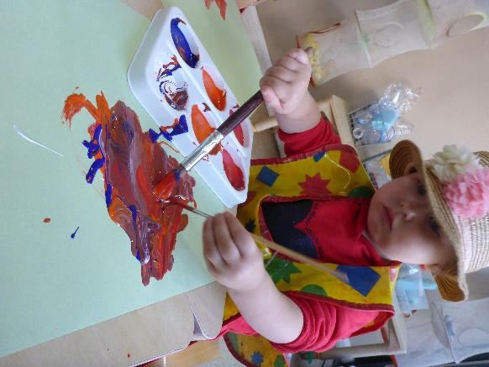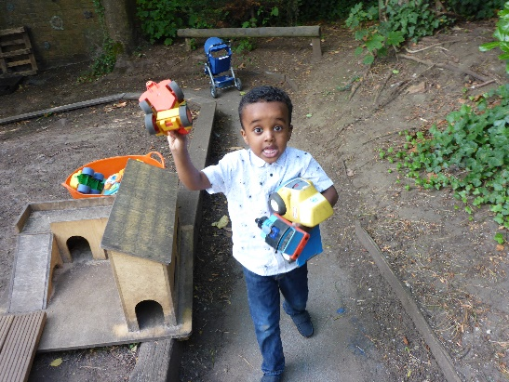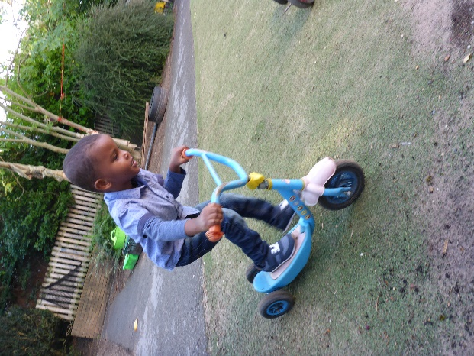
Cashmore Parents WhatsApp Group
Amran Arab (Hadaya’s Mum) has set up a Cashmore Parents WhatsApp Group. If you would like to join, please message her on 07758 945894.
Application for primary school
Please remember that the deadline for applying for a Reception Class place for your child is 15 January 2020 (if your child was born between 1 September 2015 and 31 August 2016). The Council are requesting that this is carried out online (www.bristol.gov.uk/schooladmissions). Applications are open and now is the time to be visiting local primary schools as many will have arranged open mornings/evenings. If you require any help with this, please ask.

Snack donation
The school provides milk but we rely on donations from parents for snack times during the morning and afternoon sessions. The children eat fresh fruit (e.g. apples, bananas, oranges, pears) or vegetables (e.g. carrots, cucumbers). We would be grateful if you could donate fruit weekly OR you can make a small money donation in the tin provided in Reception.

Clothes and wellies
Please could you provide your child with a pair of wellies to wear during wet play. We also ask if you could please provide your child with spare clothes in case of accidents and a coat as the weather is changeable.
Parent consultations
For children who have returned to us this academic year (and did not have a parent consultation before the summer holidays) there will shortly be an opportunity for you to have a consultation with your child’s key person. These will be during the week beginning 14 October. Please speak to your key person to book a time slot.
Important Dates
Monday 28 October to Friday 1 November – School CLOSED for half term
Monday 4 November – School CLOSED for INSET day
Return to School – Tuesday 5 November
Speech and Language Therapy drop-in – Tuesday 5 November 1.00-2.00 pm at Barton Hill Settlement

