Cashmore Early Years Centre Newsletter

December 2019

**Telephone: 0117 3534295 Facebook: Cashmore early years centre**

**Website:** [**www.cashmoreearlyyearscentre.co.uk**](http://www.cashmoreearlyyearscentre.co.uk) **Email: cashmore@bristol-schools.uk**

**Website:** [**www.cashmoreearlyyearscentre.co.uk**](http://www.cashmoreearlyyearscentre.co.uk) **Email:** [**cashmore@bristol-schools.uk**](mailto:cashmore@bristol-schools.uk)

**St Philip’s Marsh Nursery School - phone number 0117 9776171**

Thank you so much for your continued patience and understanding whilst Cashmore is closed. The children are enjoying exploring their new environment and making new friends with the children from St Philip’s.

We are doing everything we can to ensure Cashmore is open again after the Christmas holiday. **Term starts on Tuesday 7 January.** The main problem is the flat roof above the flats which is the responsibility of the Bristol City Council Housing Department. We have been assured that the necessary repairs are in hand. As soon as this work is completed the Nursery can be redecorated, new flooring installed and the damaged resources replaced. We have been assured this work will be completed with urgency.

Once again, thank you for your patience and forbearance. We will keep you updated with any new development. **We will post information on the Cashmore website and Facebook page, display a notice on the door at Cashmore and there will be information in the Cashmore Parents WhatsApp Group (see below).**

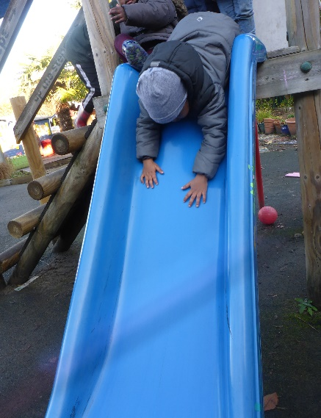 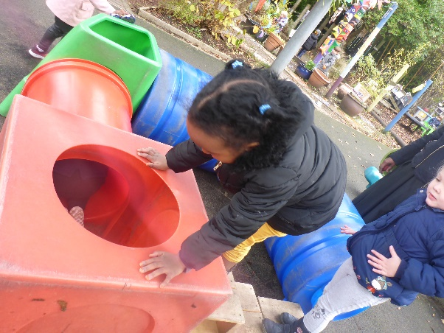 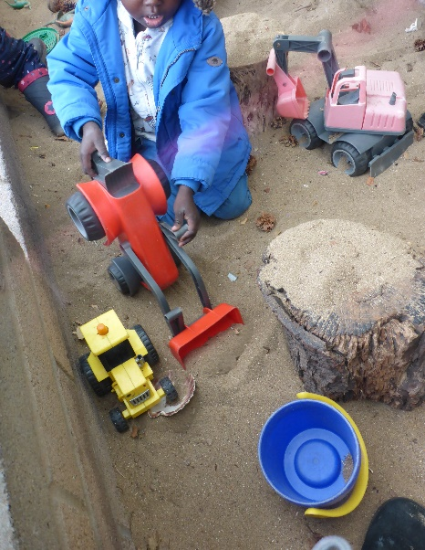

**Cashmore Parents WhatsApp Group**

Amran Arab (a parent and governor at Cashmore) has set up a Cashmore Parents WhatsApp Group. You are very welcome to join. Please message her on 07758 945894.

**Christmas parties**

**Christmas parties will be held on Monday 16 December (during the afternoon session) and Friday 20 December (during the morning session)**

We kindly ask if parents could contribute party food. We have created a list of specific packaged food that meets all of the children’s dietary requirements and allergies. Please could you inform us of your contribution via the form on reception so that we don’t end up with multiples. Parents are welcome to volunteer during the party.

Any children who do not usually attend sessions on either a Monday afternoon or Friday morning are more than welcome to join us at **one** of the parties, however, parents must stay with their child.

**Christmas Dinner - Wednesday 18 December**

All children are welcome to come to the School Christmas dinner. In order to enable this, the following arrangements apply.

All children who attend morning sessions please attend as usual. Children can then be collected at 12.30 pm.

Children who normally attend in the afternoon are invited to come in at 11:30 am until 4:00 pm as lunch will be served at 11.45 am. Please let your child’s key person know if you will be doing this.

If your child does not usually attend on a Wednesday, you are welcome to bring them in at 11:30 am and collect at 12:30 pm.

The cost of a school dinner is £2.00 and this is **payable in advance** (unless you are entitled to Free School Meals).

**Christmas sing-alongs**

We will be hosting Christmas sing-alongs this year on **Tuesday 17December at 9.20 am and Thursday 19 December at 3.20 pm**. Please come along. Mr Holmes, the Headteacher, will play guitar to accompany the singing. **This is not to entertain the children but to help with education. It helps develop hearing and listening for language and reading. It also helps to teach maths in patterns of sound and rhythm.**

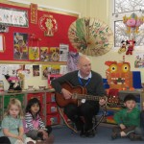

**Parking**

Your child’s safety is our number one priority at all times. We ask you to make sure that this is yours too. Every school in Bristol has an issue with parking and we are no exception. We are fortunate that we have a small car park at the front of the premises that parents can use. This can get very congested and if you are in a hurry it is best to park in a nearby side street. **PLEASE DO NOT PARK** **IN THE CAR PARKS OF LOCAL BUSINESSES (e.g. Fox Storage, Gullivers)**, not only is this very dangerous but you may well get clamped.

**Primary School Applications for September 2020**

Please remember that the deadline for applying for a Reception Class place for your child is 15 January 2020. Your child will go to Reception if they are 4 years old on or before 31 August 2020. The Council request that this is carried out on-line where possible at [www.bristol.gov.uk/schooladmissions](http://www.bristol.gov.uk/schooladmissions). Please let your child’s key person know your choices by completing the form in the classroom so that we are able to plan transitions.

**Free School Meals**

If your child is 3 and you are in receipt of certain benefits you may well be entitled to free school meals. If you think you may be entitled, please ask at Reception.

**How to prevent catching a cold**

A person with a cold can start spreading it from a few days before their symptoms begin until the symptoms have finished. The best ways to avoid catching a cold are:

* washing your hands with warm water and soap
* not sharing towels or household items (like cups) with someone who has a cold
* not touching your eyes or nose in case you've come into contact with the virus – it can infect the body this way
* staying fit and healthy

The flu vaccine helps prevent the flu but not colds. **The cold virus is not caused by playing in water/playing outside.** If children do get wet during play we change them into to dry clothes as soon as they have finished playing.

**Severe Weather**

We always try to keep the school open and plan carefully for all eventualities. However, on occasions we have had to close because of severe conditions. This is usually snow related and because of health and safety or staff shortages. If we are in a situation where we cannot open the School it will be announced on local radio stations (Radio Bristol 95.5FM), and published on the Local Authority and School websites.

C:\Users\Head\AppData\Local\Microsoft\Windows\Temporary Internet Files\Content.IE5\RZ3ISP1H\MC900303521[1].WMF[www.bristolcity.gov.uk](http://www.bristolcity.gov.uk)  
www.cashmoreearlyyearscentre.co.uk

**Post Box**

There will be a large red post box in the foyer. If your child would like to send a Christmas card to their friends, we suggest that they send **one** card to their key group. The post box will be emptied at the end of each day and the cards read out and displayed in the key group area. This saves paper and also prevents children from getting upset if they do not receive a card.

**Parent consultations**

In January we will be holding parent consultations. Please speak to your child’s key person to arrange a 10-minute meeting to talk about your child’s progress at Cashmore.

All the staff at Cashmore Early Years Centre wish you and your family a very Happy Christmas and a peaceful New Year.

