Cashmore Early Years Centre Newsletter

February 2020

**Telephone: 0117 3534295 Facebook: Cashmore early years centre**

**Website:** [**www.cashmoreearlyyearscentre.co.uk**](http://www.cashmoreearlyyearscentre.co.uk) **Email: cashmore@bristol-schools.uk**

**Website:** [**www.cashmoreearlyyearscentre.co.uk**](http://www.cashmoreearlyyearscentre.co.uk) **Email:** [**cashmore@bristol-schools.uk**](mailto:cashmore@bristol-schools.uk)

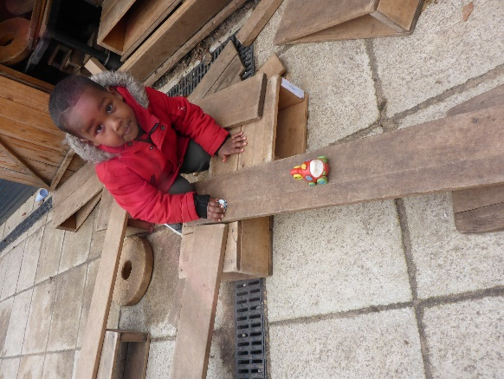 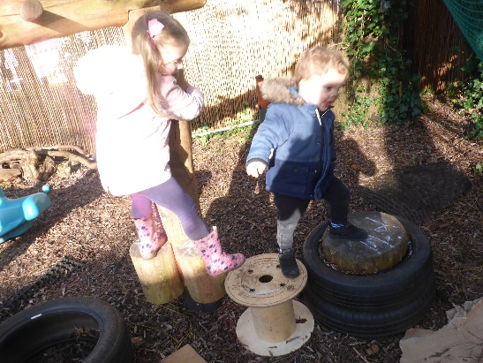 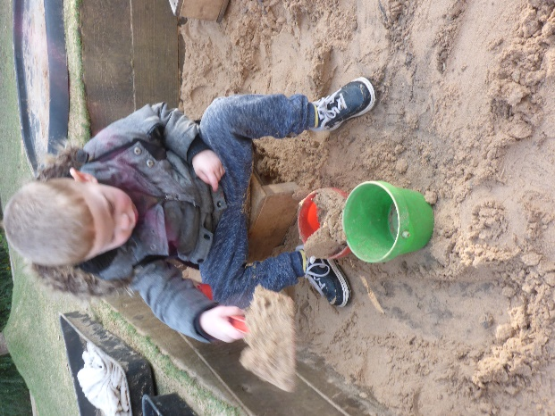

**Staff changes**

We would like to welcome Charlene Maclean who has joined us from St Philip’s. Charlene will be a key person in Zebra Group on Monday, Tuesday and Wednesday.

**School Photographer**

On Wednesday 18 March (morning) and Thursday 19 March (morning), Tempest Photography Company will be taking individual photographs and family photographs with siblings, if requested. Further details will follow in due course.   
 **C:\Users\deputy\AppData\Local\Microsoft\Windows\Temporary Internet Files\Content.IE5\8Y5WLGFR\MC900216666[1].wmf**

**Parent consultations**

After half term we will be holding parent consultations. Please speak to your child’s key person to arrange a 10-minute meeting to talk about your child’s progress at Cashmore.

**Donations**

We are looking for donations of old towels/large rags.

**Severe weather**

We always try to keep the school open and plan carefully for all eventualities. However, on occasions we have had to close because of severe conditions. This is usually snow related and because of health and safety or staff shortages. If we are in a situation where we cannot open the School it will be announced on local radio stations (Radio Bristol 95.5FM), and published on the Local Authority website and Cashmore website and Facebook page.

C:\Users\Head\AppData\Local\Microsoft\Windows\Temporary Internet Files\Content.IE5\RZ3ISP1H\MC900303521[1].WMF[www.bristolcity.gov.uk](http://www.bristolcity.gov.uk)  
www.cashmoreearlyyearscentre.co.uk

**Appropriate clothing**

We go into the garden in all weathers and children will need welly boots, waterproofs and warm coats. As a result of heavy rain, the garden can be muddy. The children play in the mud kitchen, water play, paint, use craft materials and look after the plants. We would be grateful if parents could bear this in mind when dressing their children. Please do not dress your child in their best clothes for nursery. Children will get some paint on clothes even when they wear an apron.

**Labelling clothing**

Please ensure you write your child’s name in their clothes and coats as many children have the same clothes, the same size and from the same shop.

**Absence**

If your child is going to be absent from nursery for **any** reason, please phone Cashmore (0117 3534295). If your child has sickness and/or diarrhoea they must stay off school for at least **48 hours** from the last time that they were ill. It is also the time of year for coughs and colds. If your child is unwell, please keep them at home.