CASHMORE EARLY YEARS CENTRE
SEPTEMBER 2020
A very warm welcome to all children returning to Nursery and to the children starting Nursery for the first time.
Social distancing with very young children is neither possible nor desirable. The Nursery will provide a warm, welcoming, safe secure and stimulating environment in which your child can play, learn and thrive. The emotional well-being and physical safety of your child is, as always, our highest priority.
We have taken every precaution we can, in line with government guidance, in re-opening the School to all children.
The School has been inspected by the Local Authority Health and Safety Team, which have approved our risk assessment and the measures we have introduced to ensure the School is as Covid secure as it can be. These documents are available on the school website.
There are four basic safety requirements which apply to all schools at all times. These are:
- children with Covid 19 symptoms or family members with symptoms must stay away from school;
- more frequent handwashing;
- promoting good hygiene around the use of tissues for sneezes and coughs;
- additional and enhanced cleaning.
We would greatly appreciate your support with these measures, particularly in keeping your child at home if they are at all unwell and in talking to them about why it is important to wash their hands and to use a tissue.
We are living through a time of great uncertainty and may well have to adapt and change what we are doing at very short notice. We will of course keep you fully informed of what we are doing as soon as we know. If you have any questions or concerns, please ask a member of your child’s staff team.
ParentPay
Hot meals are now available. We are now using ParentPay for parents to pay online for school meals and services. If you have not already done so, please activate your ParentPay account. Even if your child does not have hot meals, we will be using the system to send messages and information.
Staff changes
We would like to welcome Vanessa (Key Person in Zebra Group on Monday, Tuesday, Wednesday), Naznin (Early Years Support Worker on Tuesday and Wednesday) and Rachael (SMSA).
Application for primary school
Please remember that the deadline for applying for a Reception Class place for your child is 15 January 2021 (if your child was born between 1 September 2016 and 31 August 2017). The online application system is now open (www.bristol.gov.uk/schooladmissions). If you require any help with this, please ask.
Snack donation
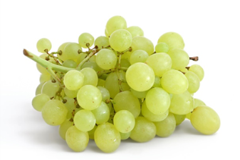
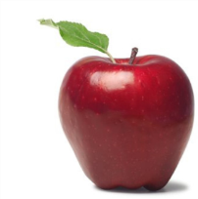
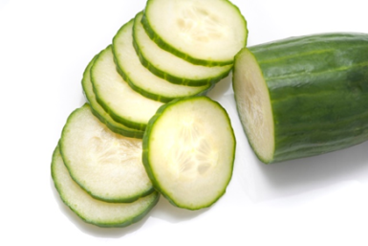
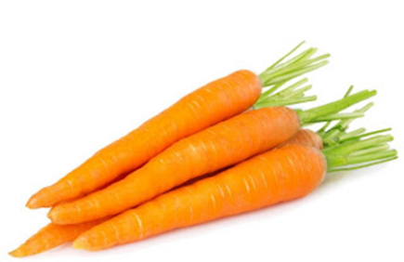
The school provides milk but we rely on donations from parents for snack times during the morning and afternoon sessions. The children eat fresh fruit (e.g. apples, bananas, oranges, pears) or vegetables (e.g. carrots, cucumbers). We would be grateful if you could donate fruit weekly OR you can make a small money donation in the tin provided in Reception or the garden.

Clothes and wellies
Please could you provide your child with a pair of wellies to wear during wet play. We also ask if you could please provide your child with spare clothes in case of accidents and a coat as the weather is changeable.
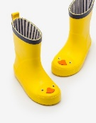
Bringing your child in to Cashmore
Thank you for abiding by social distancing guidelines and following the one-way system when dropping off and picking up your child. At drop off time, we will also be placing a trolley for each key group in the garden. Each key group trolley will be clearly labelled and each child within that key group will have a peg with their photo. Please help your child to find their photo and put their bag and coat on their peg.
Chewing gum
We do not allow children to have chewing gum in nursery as it is a choking hazard.
Important Dates
Monday 26 October to Friday 30 October – School CLOSED for half term
Return to School – Monday 2 November

