Thursday 13th June
11:15-12:15 (morning)
and
2:45-3:45 (afternoon)

We are having a party to celebrate Eid and would love for you to join us for some music, dancing and party food.
All parents and children are welcome!
We would appreciate it if everyone could bring some party food for all to share. Please note, this must be shop bought and in its packaging, so we can check the ingredients for children with allergies.
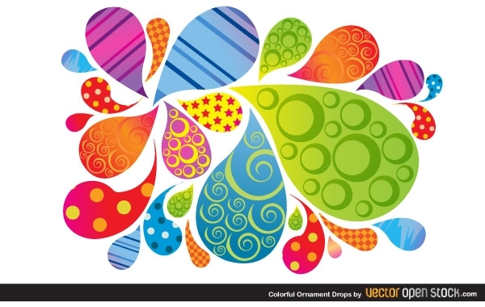
We hope you can come and look forward to celebrating with you!

