Cashmore Early Years Centre Newsletter
June 2019

Telephone: 0117 3534295 Facebook: Cashmore early years centre
Website: www.cashmoreearlyyearscentre.co.uk Email: cashmore@bristol-schools.uk
Website: www.cashmoreearlyyearscentre.co.uk Email: cashmore@bristol-schools.uk

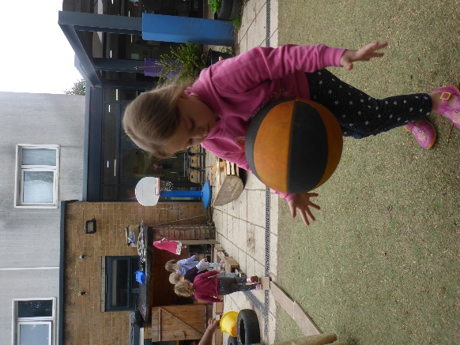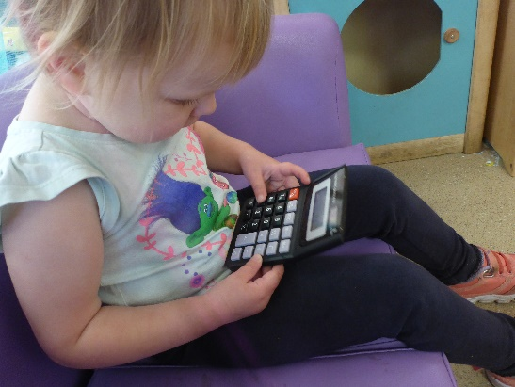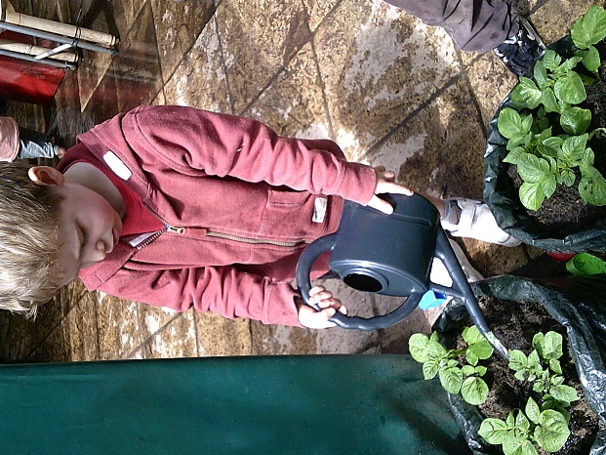
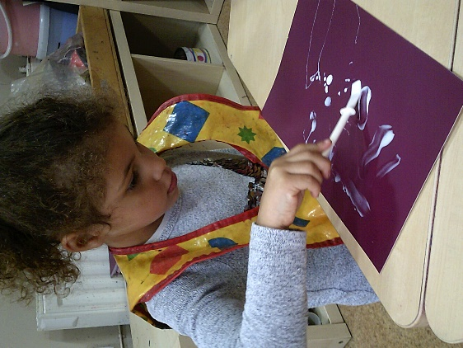 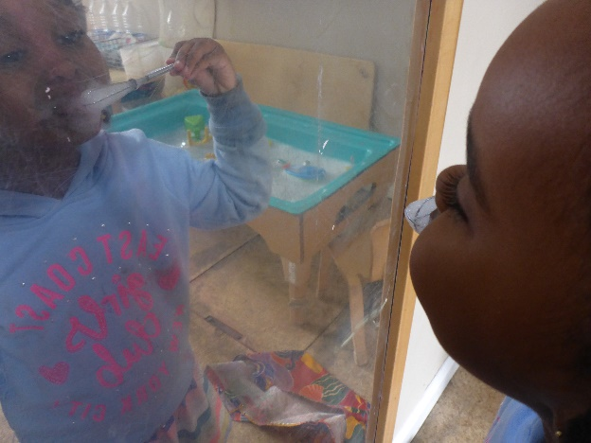 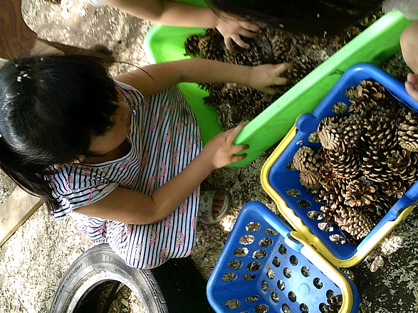
We would like to wish our families “Eid Mubarak”.
Important Dates
Wednesday 12 June – INSET Day – School CLOSED
Eid Parties – Thursday 13 June – 11:15-12:15 and 2:45-3:45 (see attached)
Wednesday 26 June – parent consultations (Tiger and Bear Groups)
Zoolab – Monday 8 July
Teddy bears leavers picnic – Wednesday 10 July 11.30 am – 12.15 pm (see attached)
“This is Our Community” celebration day – Wednesday 17 July
Last day of term – Tuesday 23 July

Summer safety
When the sun begins to shine, please make sure your child’s shoulders are covered, bring a sun hat and apply sun cream before your child comes to school. Some sun creams are available which will last all day. If your child is in all day you can send in sun cream (labelled with your child’s name) and the staff will supervise whilst they apply it themselves. It might be a good idea for them to practice this at home first. Please do not leave sun cream in your child’s bag but ensure it is given to your child’s key person.
The children spend a lot of time outside: climbing; riding bikes and scooters; playing ball games; gardening and running around. Open-toed sandals, crocs and flip flops are not suitable footwear and can be dangerous.
Parent consultations
Wednesday 26 June (from 4.15 pm) - Tiger and Bear Groups
Giraffe Group – dates/times to be arranged with key person
This is a chance to talk to your key person about your child’s learning. Please note that this is for children who are leaving in July and will NOT be returning in September. Please see your child’s key person to book a time slot.

