Cashmore Early Years Centre Newsletter
July 2019

Telephone: 0117 3534295 Facebook: Cashmore early years centre
Website: www.cashmoreearlyyearscentre.co.uk Email: cashmore@bristol-schools.uk
Website: www.cashmoreearlyyearscentre.co.uk Email: cashmore@bristol-schools.uk

We would like to take this opportunity to say goodbye and good luck to the children leaving us for ‘pastures new’ in July. To the children who will be returning to us in September, we wish you a very happy summer holiday and look forward to welcoming you back at school from Wednesday 4 September.

Thank you to everyone who attended the Eid party. It was great to see so many families joining in our celebrations: eating food; listening to music; dancing and spending time together.
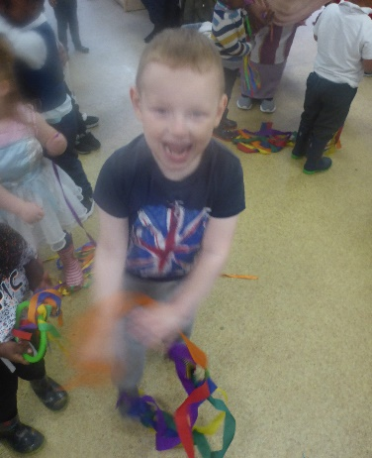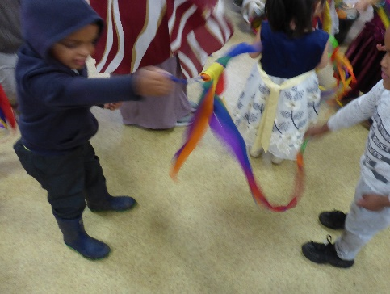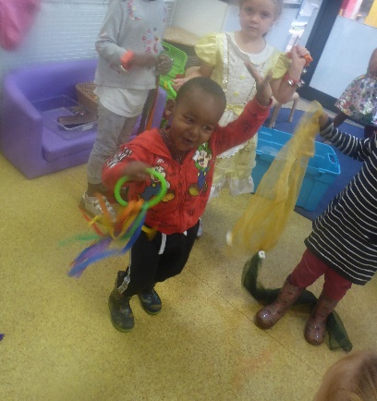
Dan from Zoolab UK recently visited the school to introduce the children to minibeasts. The children met Gail the snail, Sheila the spider, Queen the bearded dragon, John the cockroach and Titon the millipede.
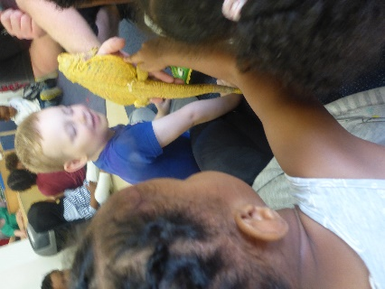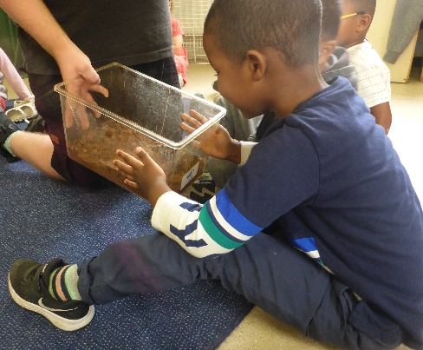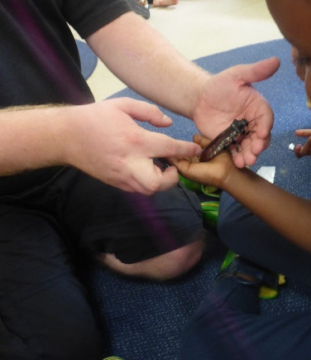
Mayoral visit
We were delighted to welcome Councillor Margaret Hickman and Marvin Rees (Mayor of Bristol) to the School recently.
He later tweeted:
“@Marg Hickman and I enjoyed our visit to St Philip’s Marsh Nursery and Cashmore EYC. Pleased that plans for nearby gas power station were stopped. Thanks to the amazing staff for their work to ensure children have the best start in life.”
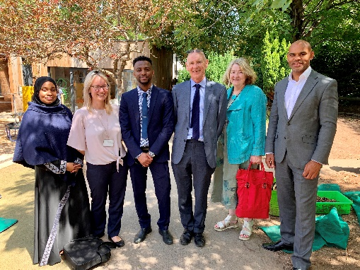

Important Dates
“This is Our Community” celebration day – Wednesday 17 July 2.00 pm at St Philip’s Marsh Nursery School, Albert Crescent, St Philip’s, BS2 0SU
Last day of term – Tuesday 23 July
INSET days Monday 2 and Tuesday 3 September – School CLOSED
Return to School – from Wednesday 4 September

