Cashmore Early Years Centre Newsletter
October 2019

Telephone: 0117 3534295 Facebook: Cashmore early years centre
Website: www.cashmoreearlyyearscentre.co.uk Email: cashmore@bristol-schools.uk
Website: www.cashmoreearlyyearscentre.co.uk Email: cashmore@bristol-schools.uk

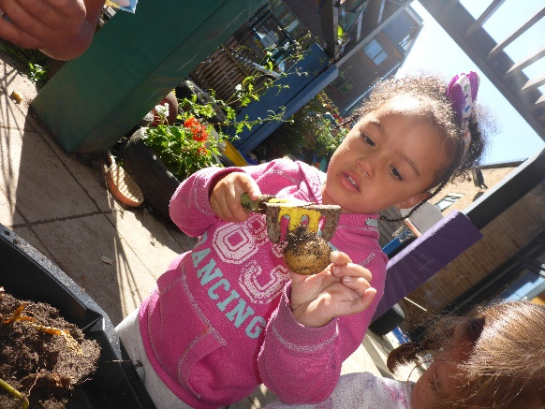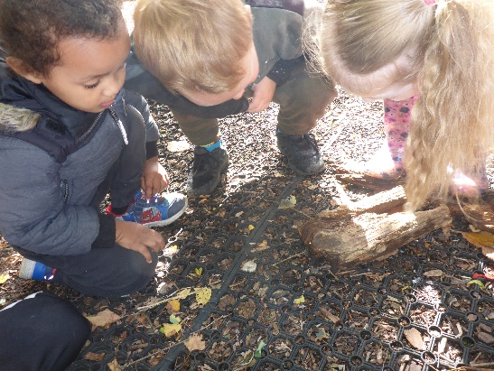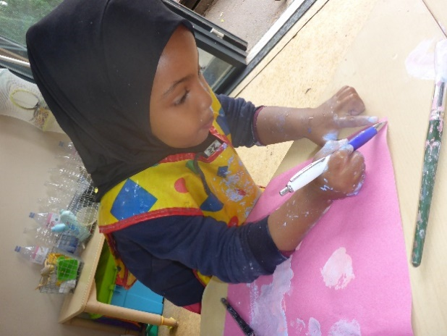
Staff changes
We would like to welcome Caroline who will be the Key Person in Zebra Group on Monday, Tuesday and Wednesday covering Amy’s maternity leave.
Naciima begins her maternity leave shortly and we would like to wish her the very best of luck and look forward to meeting her baby soon.
Application for primary school
Please remember that the deadline for applying for a Reception Class place for your child is 15 January 2020 (if your child was born between 1 September 2015 and 31 August 2016). The Council are requesting that this is carried out online (www.bristol.gov.uk/schooladmissions). Applications are open and now is the time to be visiting local primary schools as many will have arranged open mornings/evenings. If you require any help with this, please ask.

James Britton from the LA (School Admissions) will be running an advice session for parents at 2:30 pm on 18 November at St Philip's Marsh Nursery School. The brief presentation will cover:
- How to apply
- Information available to help your choice
- The importance of making 3 choices
- What happens if you miss out?
- The pointlessness of appealing (in most cases)
- Deferral and delay

School meals price increase
The new price for a school meal will be £2.00 from Monday 4 November 2019. A new menu is also available at Reception.
Buy back sessions
We are currently reviewing our pricing structure for buy back sessions. The new pricing structure will come in to effect in January 2020.
Parking
Please do not double park/block cars in (even for a short time) outside the Centre as it is causing frustration to the local residents.
2-year olds enter through the garden
Please can we remind parents with 2-year olds that they bring their children through the garden at the beginning of their session. The gate is open from 9.00 - 9.30 am and 1.00 - 1.15 pm. Pick-up at the end of the session is through the main Reception.
Snack donation
Thank you to the parents who continue to donate to the children’s snack time. The school provides milk but we rely on donations from parents for snack times during the morning and afternoon sessions. The children eat fresh fruit (e.g. apples, bananas, oranges, pears) or vegetables (e.g. carrots, cucumbers). We would be grateful if you could donate fruit weekly OR you can make a small money donation in the tin provided in Reception/2-year old area.

Clothes and footwear
The weather is very changeable at the moment so please ensure your child always brings a coat to school. As the weather gets colder, children will need appropriate warm clothing, a change of clothes and wellies as we go into the garden in all weathers. Please could you also ensure you have provided enough nappies for your child’s session.
Thank you to the parents who have supplied their children with waterproof clothing and wellies. This has meant that the children have continued to explore the garden whatever the weather.
Shadow Secretary of State for Education visit
We recently welcomed Angela Rayner (Shadow Secretary of State for Education) and Thangam Debbonaire (MP for Bristol West) to the Centre. They met some of the children and staff and thanked the staff for the amazing care, support and education given to the children and their families in the area.
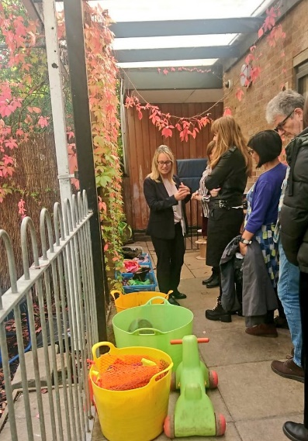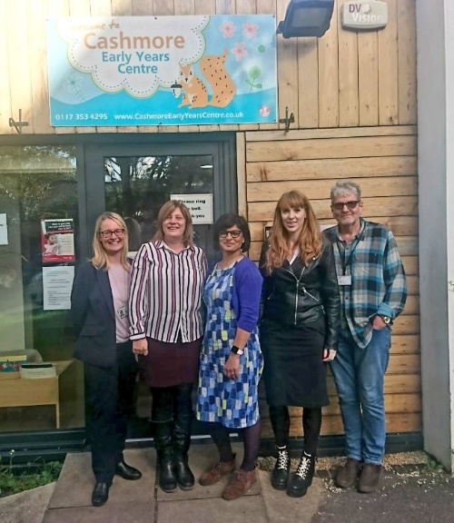
Important Dates
Monday 28 October to Friday 1 November – School CLOSED for half term
Monday 4 November – School CLOSED for INSET day
Return to School – Tuesday 5 November
Speech and Language Therapy drop-in – Tuesday 5 November 1.00-2.00 pm at Barton Hill Settlement

At Cashmore Early Years Centre we are committed to safeguarding and promoting the welfare of children and young people. This is our safeguarding team.

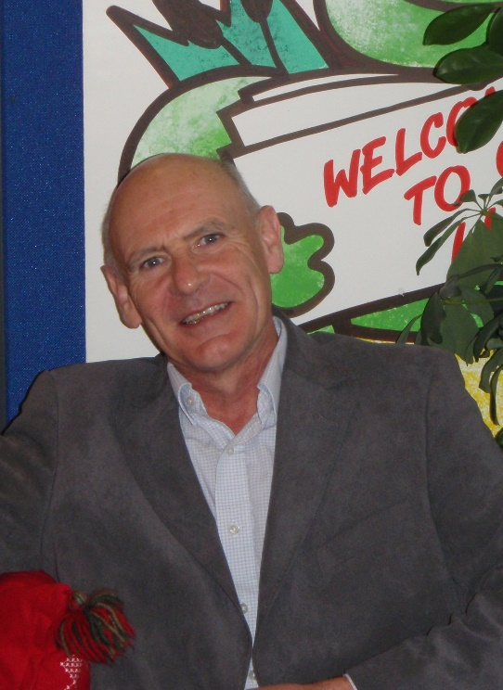
Simon Holmes – Headteacher Denise Draper – Deputy Headteacher
Designated Safeguarding Lead Deputy Safeguarding Lead

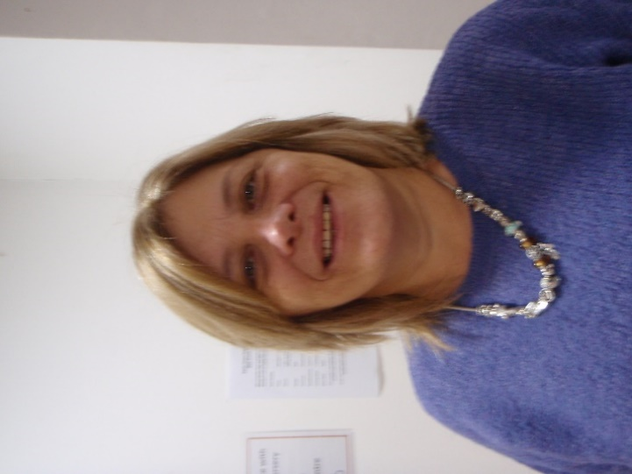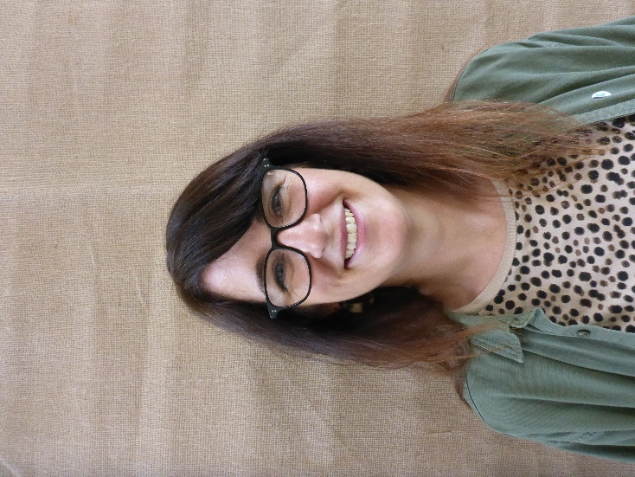
Sharon Cutler – School Business Manager Tracey Gudonis – Governor
Deputy Safegurding Lead Named Safeguarding Governor

