Cashmore Early Years Centre Newsletter

November 2019

**Telephone: 0117 3534295 Facebook: Cashmore early years centre**

**Website:** [**www.cashmoreearlyyearscentre.co.uk**](http://www.cashmoreearlyyearscentre.co.uk) **Email: cashmore@bristol-schools.uk**

**Website:** [**www.cashmoreearlyyearscentre.co.uk**](http://www.cashmoreearlyyearscentre.co.uk) **Email:** [**cashmore@bristol-schools.uk**](mailto:cashmore@bristol-schools.uk)

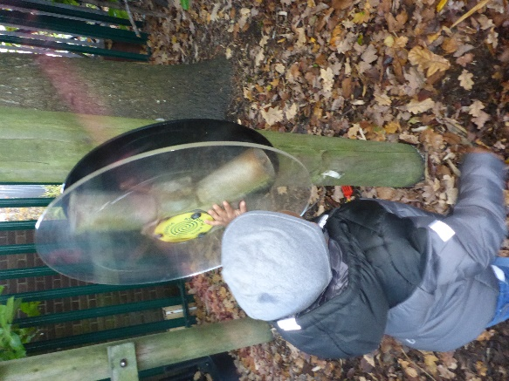 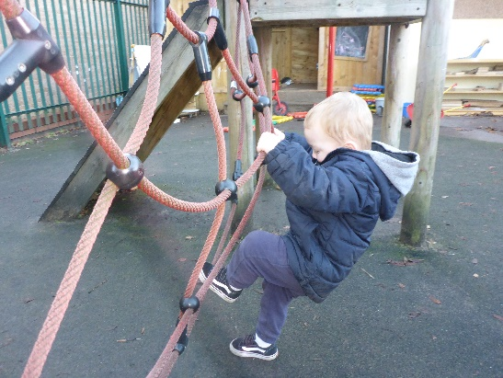 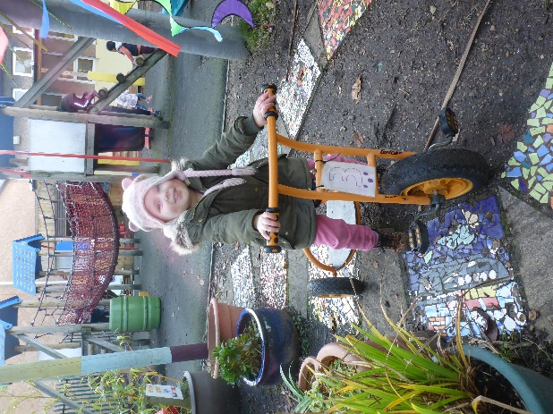

Thank you so much for your co-operation whilst Cashmore is closed. It will be closed until further notice whilst the contractors renovate it after the water damage (most probably until Christmas). The children have settled in well at St Philip’s and are especially enjoying the large outdoor space. We apologise for any inconvenience. We appreciate your commitment and patience and will keep you updated as we know more. If you have any difficulty with the above arrangements, please speak to a member of staff and we will do what we can to help.

**Application for primary school**

Please remember that the deadline for applying for a Reception Class place for your child is 15 January 2020 (if your child was born between 1 September 2015 and 31 August 2016). The Council are requesting that this is carried out online ([www.bristol.gov.uk/schooladmissions](http://www.bristol.gov.uk/schooladmissions)). Applications are open and now is the time to be visiting local primary schools as many will have arranged open mornings/evenings. If you require any help with this, please ask.

**School meals price increase**

The new price for a school meal is **£2.00 (paid in advance).** A new menu is also available at Reception.

**Buy back sessions**

The new price for a 3-hour session will be £22.00 (the morning session is 9.15am-12.15pm and the afternoon session is 1.00-4.00 pm). This will come in to effect on 6 January 2020.

**Parking**

Your child’s safety is our number one priority at all times. We are fortunate to have a small car park at St Philip’s but it can get very busy and, if you are in a hurry, it is best to park in a nearby side street. **PLEASE DO NOT PARK** **IN THE CAR PARKS OF LOCAL BUSINESSES (e.g. Gullivers, Fox Storage)**. Not only is this very dangerous but you may well get clamped.

**Snack donation**

Thank you to the parents who continue to donate to the children’s snack time. The school provides milk but we rely on donations from parents for snack times during the morning and afternoon sessions. ****The children eat fresh fruit (e.g. apples, bananas, oranges, pears) or vegetables (e.g. carrots, cucumbers). We would be grateful if you could donate fruit weekly **OR** you can make a small money donation in the tin provided.



**Clothes and footwear**

The weather is very changeable at the moment so please ensure your child always brings a coat to school. As the weather gets colder, children will need appropriate warm clothing, a change of clothes and wellies as we go into the garden in all weathers. Please could you also ensure you have provided enough nappies for your child’s session.

Thank you to the parents who have supplied their children with waterproof clothing and wellies. This has meant that the children have continued to explore the garden whatever the weather.

**Christmas parties**

We will host two parties:

Party 1 – Monday 16 December - PM  
Party 2 – Friday 20 December - AM

Further details to follow in the December Newsletter.

**Christmas dinner**

Christmas dinner is going to take place on **Wednesday 18 December**. If your child does not normally attend on this day they can attend for Christmas dinner. Further details will follow in due course.

There will be a list available in each key group that you will need to sign so that we can order the correct number of turkeys (this needs to be done by the beginning of December). The cost of a school dinner is £2.00 and this is payable **in advance** (unless you are entitled to Free School Meals).

**Christmas sing-alongs**

We will be hosting Christmas sing-alongs this year on **Tuesday 17December at 9.20 am and Thursday 19 December at 3.20 pm**. Please come along.

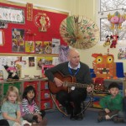

Please see your child’s key person if you have any questions or queries regarding any of the above arrangements.