Cashmore Early Years Centre Newsletter

January 2020

**Telephone: 0117 3534295 Facebook: Cashmore early years centre**

**Website:** [**www.cashmoreearlyyearscentre.co.uk**](http://www.cashmoreearlyyearscentre.co.uk) **Email: cashmore@bristol-schools.uk**

**Website:** [**www.cashmoreearlyyearscentre.co.uk**](http://www.cashmoreearlyyearscentre.co.uk) **Email:** [**cashmore@bristol-schools.uk**](mailto:cashmore@bristol-schools.uk)

**Welcome back to Cashmore and Happy New Year to all our families**

 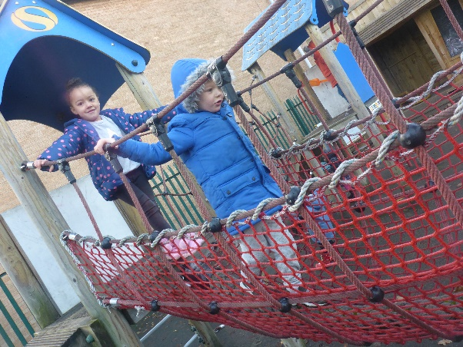 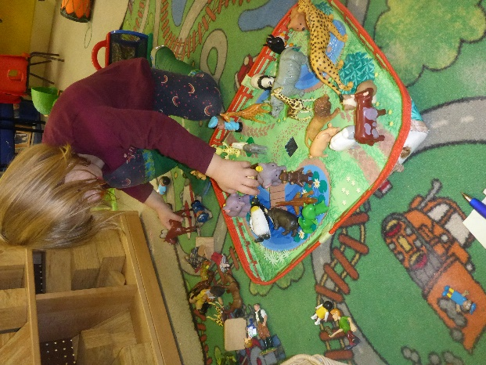

We are delighted to be back at Cashmore and the children are settling well into the renovated environment. Thank you for your understanding and patience during this difficult time.

**Free School Meals**

If your child is 3 and you are in receipt of certain benefits you may well be entitled to free school meals. Please ask at Reception for further information.

**Cold weather**

Please can we remind parents to provide hats, gloves, scarves, wellies, waterproofs and warm coats during this cold, wet weather.

**Children’s bags**

Please ensure that there is always a bag on your child’s peg which contains at least one change of clothes. If your child is wearing nappies, please ensure that there are sufficient nappies and wipes in the bag.

**Donations**

Thank you to the parents who continue to donate to the children’s snack time. The school provides milk but we rely on donations from parents for snack times during the morning and afternoon sessions. ****The children eat fresh fruit (e.g. apples, bananas, oranges, pears) or vegetables (e.g. carrots, cucumbers). We would be grateful if you could donate fruit weekly **OR** you can make a small money donation in the tin provided in Reception or in 2-year old area. Your donations are greatly appreciated.



**We are also looking for donations of old towels/large rags.**

**This term**

This week we have been celebrating Chinese New Year (Year of the Rat).

**Severe weather**

We always try to keep the school open and plan carefully for all eventualities. However, on occasions we have had to close because of severe conditions. This is usually snow related and because of health and safety or staff shortages. If we are in a situation where we cannot open the School it will be announced on local radio stations (Radio Bristol 95.5FM), and published on the Local Authority and School websites and School Facebook page.

C:\Users\Head\AppData\Local\Microsoft\Windows\Temporary Internet Files\Content.IE5\RZ3ISP1H\MC900303521[1].WMF[www.bristolcity.gov.uk](http://www.bristolcity.gov.uk)  
[www.cashmoreearlyyearscentre.co.uk](http://www.cashmoreearlyyearscentre.co.uk)

**Parent consultations**

In February we will be holding parent consultations. Please speak to your child’s key person to arrange a 10-minute meeting to talk about your child’s progress at Cashmore.